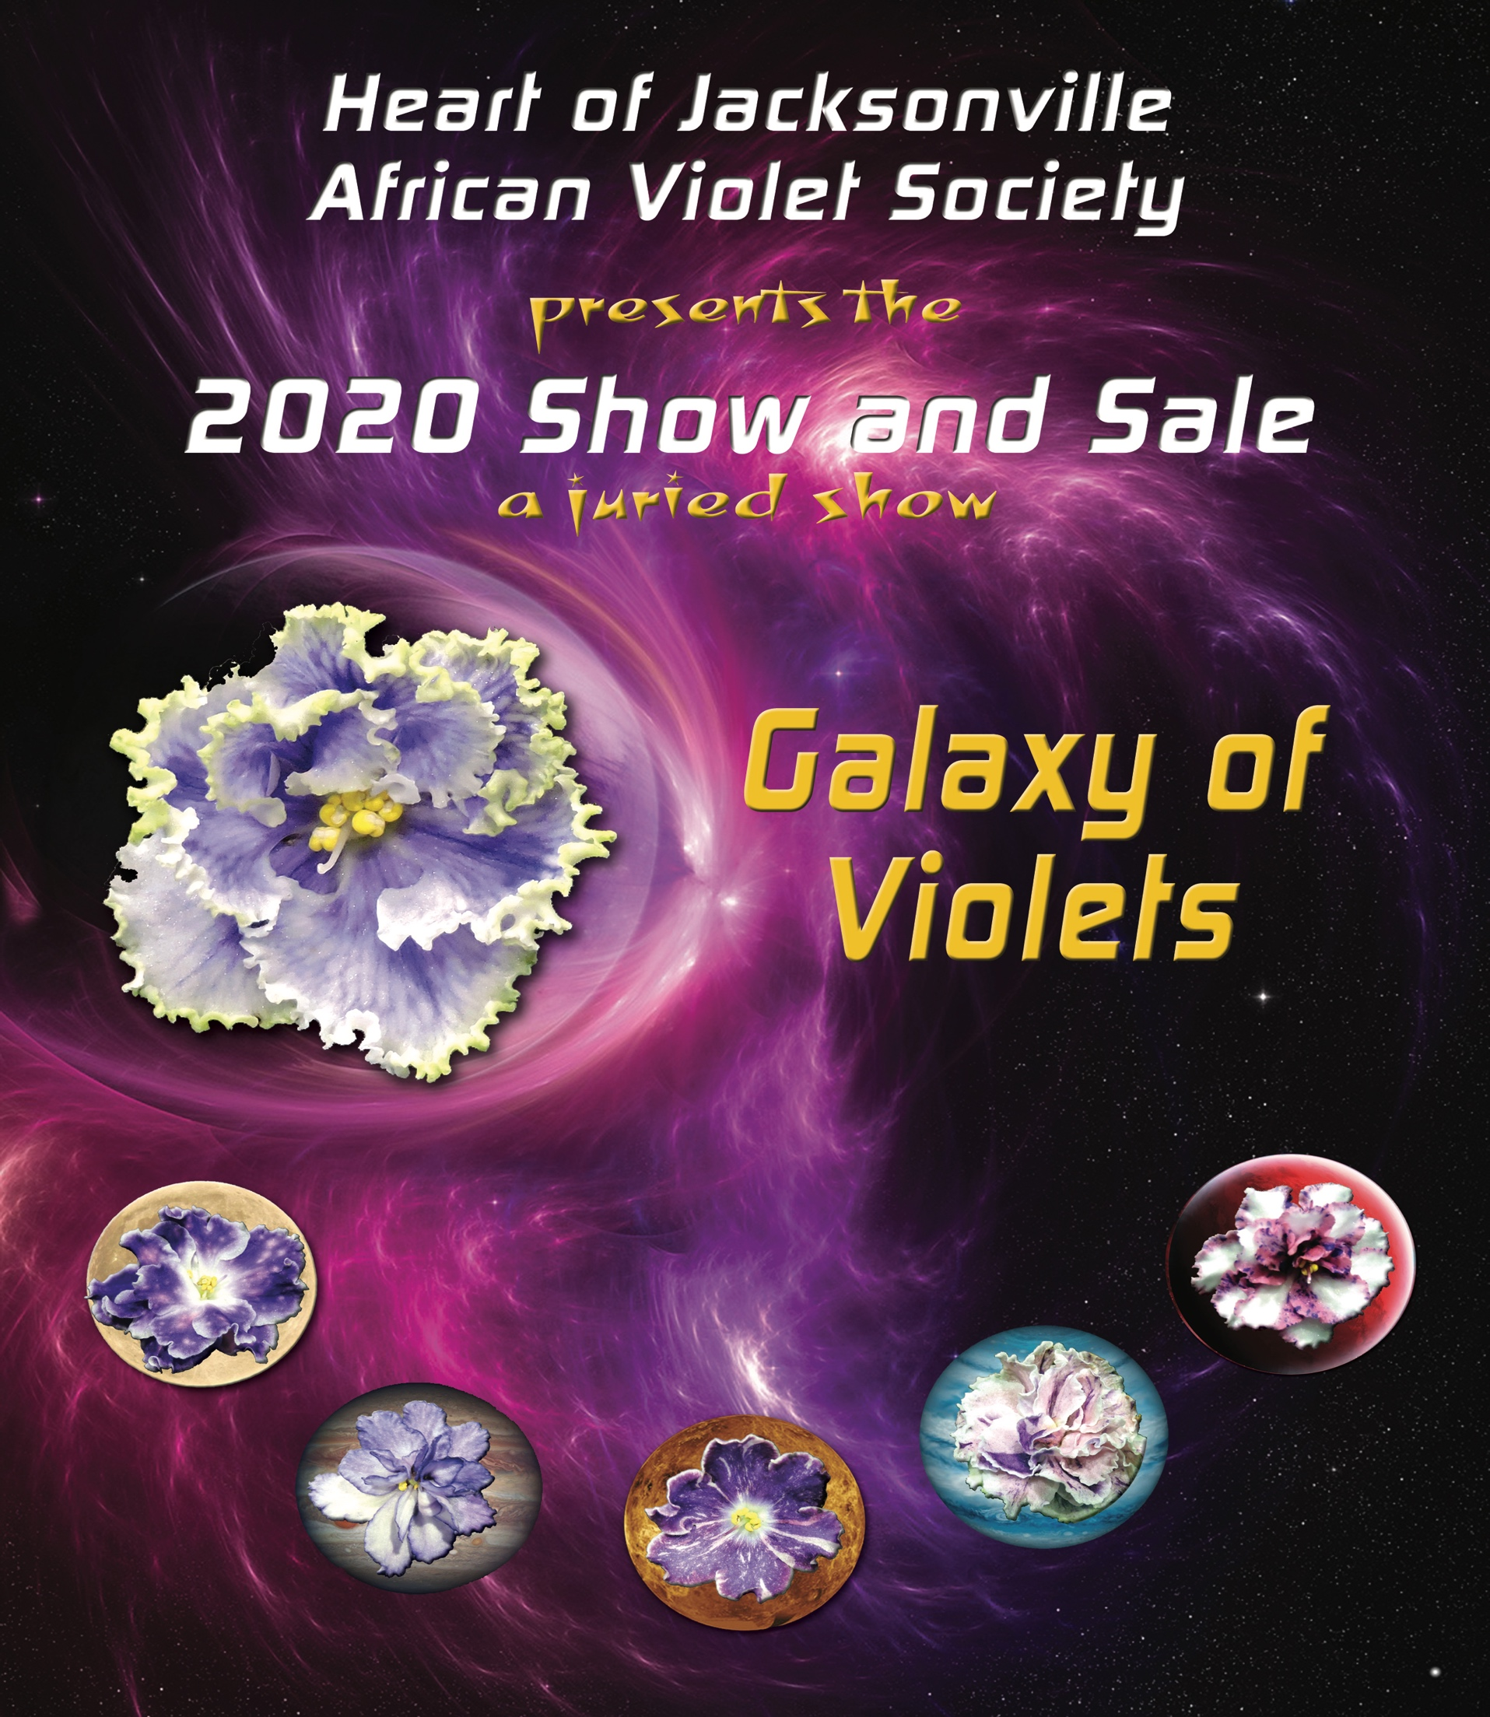

Galaxy of Violets
A Juried Show

Heart of Jacksonville African Violet Society
2019 Annual Plant Show and Sale

March 27th, 2019 from 12:00pm – 5:00pm

March 28th, 2019 from 10:00am – 4:00pm
San Jose Church of Christ
6233 San Jose Blvd.
Jacksonville, FL 32217

Show Committee Chairs

Show Chair Sharon Gartner
Schedule/Rules Cathy Carter, Bobbi Johannsen, Sharon Gartner
Awards Linda McQueen
Classifications Cathy Carter, Linda McQueen
Entries Carol Hixenbaugh, Sharon Gartner
Greeter…………….……………….……………………………………..Shipra Panda
Hospitality Carol McBryde, Janice Holinyj
Judges and Clerks Cathy Carter
Publicity Patrick Greenstreet
Placement Sandra Brinson, Janice Holinyj
Sale Plant Sales Beverly Stormoen, Joann Freeman
Show Plant Sales Bobbi Johannsen
Supply Sales Patrick and Taf Greenstreet
Staging and Properties Bobbi Johannsen, Carol McBryde
Education Sandra Brinson, Janice Holinyj
Focal Point Sandi Mynatt
Cashiers Carol McBryde, Shirley Peck, Carol Hixenbaugh, Linda McQueen
Setup Everyone
Clean-up Everyone

Officers
President - Sharon Gartner
First Vice President - Cathy Carter
Second Vice President – Taf Greenstreet
Recording Secretary - Shirley Peck
Treasurer - Carol Hixenbaugh

Rules for Horticultural Division

- Only members of Heart of Jacksonville African Violet Society are eligible to enter exhibits in the show.
- Members bringing sale plants must participate by entering plants or volunteering their time during the show.
- This show will be merit judged per AVSA rules set forth in the AVSA Handbook for African Violet Growers, Exhibitors, and Judges, which will be the authority for cases not covered by specific rules in the schedule. Only accredited AVSA Judges will judge exhibits and their decision is final.
- Entries (including all Design entries) must be made on Thursday, March 26th , from 12:00 p.m. to 6:00 p.m. according to pre-announced schedule. Finishing touches ONLY to Design entries may be made Friday, March 27th between 7:00 and 8:00 a.m.
- All exhibitors must report to the Classification Committee during the designated hours. Entry sheets must be filled out ahead of time, in pencil, and presented to the Classifications Committee. Any corrections in the name of the plant will be made at that time. The Classifications Committee will make corrections to the sheets and hand them to Entries Committee. Entries will print the cards and name tags and hand them back to the exhibitor. The exhibitor will be given the name tag to place on the plant and the entry card. The plant with name tag and card will then be passed to the Placement Committee, to be placed in the proper section and class on the show tables.
- If exhibits are entered by someone other than the owner, the name of such person must be listed on the back of the entry card.
- Judging will begin promptly at 9:00 a.m. on Friday, March 27th. Only Judges, Clerks, Judges Chair, Show Chair and Classifications Chair are permitted in the show area during judging. All plant material must be clean and free of insects and diseases. All entries, including sale plants, will be inspected by Classification or Plant Sales chairs.
- Supports or collars under foliage will not be permitted, except for hanging baskets and other Gesneriads. Moist-Rites and Oyama pots are permitted but Dandy pots are not allowed. All other pots must be slip-potted with clean, similarly colored, plastic, neutral tone (white, green, black etc.) pots. Slip-potting means dropping the pot containing the plant into a clean pot of the same or just a fraction-larger-sized pot. To prevent leakage, plastic wrap must cover any holes in the inner pot. Exhibitor # and name of the plant should be placed where it will not show. Only trailers, trailing species and other Gesneriads, may be exhibited in the containers in which they were grown, but pots must be clean and neutrally colored. Drain holes must be sealed, in an inconspicuous way, to prevent leakage.
- Protective covers, mulches and unobtrusive stakes are permitted for Gesneriads, other than African violets. Gesneriads entered in Classes 42, 43, and 44, must have some special quality of foliage, coloring, texture, growth habit, etc., and not be just a Gesneriad out of bloom. Seed pods are acceptable on other Gesneriads when decorative but should be in sufficient number to indicate that they are purposely retained.
- All African violets must be in bloom (except class 47). All specimen plants must be single crowned plants except those which do not grow in the classic rosette form, such as species, trailers, and other Gesneriads.
- All plants must have been grown by and in the possession of the exhibitor for at least three months prior to the show, except those used in the Design Division.
- Exhibitors may make more than one entry in the Horticulture Division Classes, providing each is a different variety within each class. The Classification Committee may combine or divide classes where number of entries warrants.

- Only AVSA members in good standing are eligible to enter AVSA Collection Classes. Current year’s AVSA membership card must be presented at time of entry. Only one collection in each class per exhibitor is permitted. A collection will consist of three different registered African violets of the same type, with registration numbers included on the entry sheet. Each plant will be point scored and awarded ribbons as merited. Blue ribbon plants are eligible for other awards.
- Only DIXIE members in good standing are eligible to enter DIXIE Collection Classes. Only one collection in each class per exhibitor is permitted. A collection will consist of three different DAVS registered African violets of the same type, with registration numbers included on the entry sheet. Each plant will be point scored and awarded ribbons as merited. Blue ribbon plants are eligible for other awards.
- For plant classification: Edged takes precedence over fantasy and chimera. Chimera has precedence over fantasy.
- Violets entered in the Unusual Container Class 29 will be merit judged and must have been in the exhibitor’s possession for at least three months, but not necessarily planted in the container for three months. The entry need not suggest the show theme. Only one entry per exhibitor in this class.
- Classes 27 and 28, seedlings and sport mutation classes, must not have been shown at a prior HJAVS show. Seedlings must have been originated by the exhibitor, or the right to them must have been released in writing by the originator to the exhibitor. Plants grown from purchased seed are the property of the grower, and it is not necessary to obtain permission from seed’s producer. Sports or mutants will be exhibited as “Sport of ___________”. If it has been named, the name will follow in the parentheses.
- Only blue ribbon exhibits will be eligible for special awards. There will be Best in Class ribbons. The AVSA Gold and Purple Rosettes will be awarded to the Best and Second-Best AVSA Collection in Classes 1,2 and 3. The DAVS Best and Second-Best collection ribbons will be awarded in Classes 4 and 5. Each plant in all collections must score at least 90 points to qualify. Sweepstakes Awards will be given to the winners of the most blue ribbons in the Horticulture Division. In case of a tie, red then white ribbons will be counted.
- The show will be open on Friday, March 27th from 12:00pm until 5:00pm and Saturday, March 28th from 10:00am until 4:00pm. Sold show plants may not be removed before 2 pm on Saturday.
- HJAVS will provide all reasonable protection to exhibits but will not be responsible for any damage or loss.

Rules for Design Division

- An exhibitor may have only one entry in each class. All entries must be included in the member entry sheet provided to the Classification Committee.
- The American flag, state flags, flags of other nations, plants on the endangered species list from any state or nation, artificial plant material, and creatures living, or dead are not permitted in any design exhibit.
- African violet plants and other plant material used need not have been grown by the exhibitor.
- All entries in the Design Division must have a 3”x5” card listing the African violet varieties and other plant material used. A subtitle or written interpretation of the design may be provided on a separate 3”x5” card but is not required.
- All designs must be the creation of the exhibitor and must be entered and placed by the exhibitor.
- To assist in staging, reservations for the Design Division must be made by March 20th. Reserve space by calling Sharon Gartner 536-4182.

Horticulture Division

SECTION I. COLLECTIONS
Class 1. AVSA Collection Standard. A collection of three different AVSA registered standard varieties of the same type: 3 single-crown or three trailers.
Class 2. AVSA Collection Semiminiature and Miniature. A collection of three different AVSA registered varieties of the same type: 3 single-crown miniatures, 3 miniature trailers, 3 single-crown semiminiature, or 3 semiminiature trailers.
Class 3. AVSA Collection of three different species of any type.
Class 4. DIXIE Collection Standard. A collection of three different DIXIE registered standard varieties of the same type: 3 single-crown or 3 trailers.
Class 5. DIXIE Collection Semiminiature and Miniature. A collection of three different DIXIE registered varieties of the same type: 3 single-crown miniatures, 3 miniature trailers, 3 single-crown semiminiature, or 3 semiminiature trailers.

SECTION II. STANDARD SPECIMEN PLANTS, ANY TYPE BLOSSOMS, GREEN FOLIAGE

Class 6. Solid color
Class 7. Two-tone
Class 8. Multi-colored
Class 9. Edged
Class 10. Fantasy
Class 11. Chimera

SECTION III. STANDARD SPECIMEN PLANTS, ANY TYPE BLOSSOMS, VARIEGATED FOLIAGE

Class. 12. Solid color
Class 13. Two-tone
Class 14. Multi-colored
Class 15. Edged
Class 16. Fantasy
Class 17. Chimera

SECTION IV. SEMIMINIATURE SPECIMEN PLANTS, ANY TYPE FOLIAGE AND BLOSSOMS

Class 18. Solid Color and two-tone blossoms, any color
Class 19. Multi-colored and Edged
Class 20. Fantasy and Chimera

SECTION V. MINIATURE SPECIMEN PLANTS, ANY TYPE FOLIAGE AND BLOSSOMS

Class 21. Solid Color and two-tone blossoms, any color
Class 22. Multi-colored and Edged
Class 23. Fantasy and Chimera

SECTION VI. TRAILERS AND SPECIES, ANY TYPE FOLIAGE AND BLOSSOMS

Class 24. Standard Trailer
Class 25. Semiminiature and Miniature Trailer
Class 26. Saintpaulia species and natural hybrids

SECTION VII. NEW CULTIVARS (See rule #17)

Class 27. Seedlings
Class 28. Sports or mutants

SECTION VIII. AFRICAN VIOLET PLANT IN UNUSUAL DECORATIVE OR NOVEL CONTAINER (See rule #16)

Class 29. One African violet plant or trailer, either standard, miniature or semiminiature
planted in a decorative container.

SECTION IX. SPECIAL CLASSES

Class 30. Vintage violets (over 25 years, before 1994)
Class 31. Wasps
Class 32. African violets grown in natural light
Class 33. Novice HJAVS members who have never displayed in horticulture
(Novices may also enter in other classes)
Class 34. Project Plant

SECTION X. GESNERIADS OTHER THAN AFRICAN VIOLETS (See rules #8 and #9)

Class 35. Miniatures, any type blooming
Class 36. Tuberous, blooming
Class 37. Rhizomatous, blooming
Class 38. Streptocarpus, blooming
Class 39. Episcia, blooming
Class 40. Primulina, blooming
Class 41. Any other Gesneriads Fibrous-rooted, blooming
Class 42. Episcia grown for ornamental foliage, non-blooming (See rule #9)
Class 43. Primulina grown for ornamental foliage, non-blooming (See rule #9)
Class 44. Any other Gesneriads grown for ornamental foliage, non-blooming (See rule #9)

SECTION XI. SPECIAL EXHIBITS

Class 45. Education and AVSA information Exhibits

Design Division
“Galaxy of Violets”

SECTION XII. INTERPRETIVE PLANT ARRANGEMENT

Each exhibit in this section is a design using one or more African violet plants, removed from their pots, with the root balls encased in plastic or some other material. Dried, treated, painted, colored and fresh-cut plant materials, are permitted. Man-made materials that do not simulate plants are permitted. However, artificial plant material, live or dead creatures and national flags are not permitted. Accessories, backdrops and/or draping are permitted unless restricted by a class description. Sides of niches (where applicable) may not be used.

Class 46. Saturn's rings - Gossamer particles of dust and ice colorfully arranged in contrasting rings reflect the sun's brilliance. Symmetrical and captivating, this incredible sight compels many to study the heavens. A blooming plant arrangement in a white foam board niche 27.5” high by 20” wide by 9.5” deep (15” may be used for the depth of the niche).

Class 47. Milky Way - The Milky Way, Earth's own galaxy, is our Home-Sweet-Home in the universe. A flat galaxy with four spiral arms, it is a vast collection of stars, dust, gas, darkness and light surrounded by infinite space. A non-blooming plant arrangement in a white foam board niche 27.5” high by 20” wide by 9.5” deep (15” may be used for the depth of the niche).

SECTION XIII. INTERPRETIVE FLOWER ARRANGEMENT

Each exhibit in this section is a design using fresh cut African violet blossoms. Dried, treated, painted, colored and fresh-cut plant materials, are permitted. Man-made materials that do not simulate plants are permitted. However, artificial plant material, live or dead creatures and national flags are not permitted. Accessories, backdrops and/or draping are permitted unless restricted by a class description. Sides of niches (where applicable) may not be used.

Class 48. Shooting stars - Make a wish! The brilliant streak of a shooting star awakens childlike delight in everyone lucky enough to catch a glimpse. An underwater design completely submerged in water and displayed in a clear transparent container of the designer’s choice. Staged at eye level, viewed from the front only. Not to exceed 12” in any direction. No backdrop or underlay allowed.

Class 49. Nebulae - Mysterious reflective clouds of swirling gasses and interstellar dust are the birthplace of new stars or the remains of explosive dying stars. Nebulae have subtle, delicate beauty. Create an arrangement using African violet flowers in a white foam niche 14” high by 10” wide by 5” deep (10” may be used for the depth of the niche).

Class 50. Constellations - Since history began, humans have discerned and named patterns among the starry night sky. From the Big Dipper to the Zodiac, imagination weaves stories to guide and captivate the earthbound. A hanging arrangement in a white foam board niche 27.5” high by 20” wide by 9.5” deep (15” may be used for the depth of the niche). Designers provide their own dowel rods or mechanics.

SECTION XIV. CONTAINER GARDENS

Each exhibit in this section is a miniature landscape with one or more blooming African violet plants and other growing material. All plants must be planted within the container. No cut plant material, artificial plant material, cacti, succulents, live or dead creatures, or national flags are permitted. Accessories and landscaping elements are permitted. No decorative bases are allowed.

Class 51. Terrarium - Planting under glass
Class 52. Dish Garden - Planting in a dish
Class 53. Natural Garden - Planting in a natural container

AWARDS

Best AVSA Collection Standard
Second Best AVSA Collection Standard
Best AVSA Collection Semi-Miniature and Miniature
Second Best AVSA Collection Semi-Miniature and Miniature
Best AVSA Collection Species
Second best AVSA Collection Species
B Best DIXIE Collection Standard
Second Best DIXIE Collection Standard
Best DIXIE Collection Semi-Miniature and Miniature
Second Best DIXIE Collection Semi-Miniature and Miniature
Best in Show Horticulture
Best in Show Design
Best in Horticulture Sweepstakes
Second Best in Show
Second Best in Horticulture Sweepstakes
Award of Merit (awarded at Judges Discretion)
Best Novice
Best Standard
Best Semi-Miniature
Best Miniature
Best Trailer
Best Species
Best Gesneriad
Second Best Gesneriad
Best Chimera
Best Optimara
Best in Section
Best in Class
Best Project Plant
People’s Choice African Violet
People’s Choice Gesneriads People’s Choice Design
Ps

